1. **what is mount and unmount in react.**
   1. Mounting and unmounting are two important concepts in React. Mounting refers to the process of adding a component to the DOM, while unmounting refers to the process of removing a component from the DOM.
2. **What is reactive values?**
   1. Props, state, and variables declared inside your component’s body are called reactive values. In this example, **serverUrl** is not a reactive value, but **roomId** and **message** are. They participate in the rendering data flow:
   2. 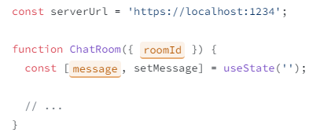
   3. Logic inside event handlers is not reactive.
   4. Logic inside Effects is reactive
3. **What is useEffects Hook and explain.**
   1. 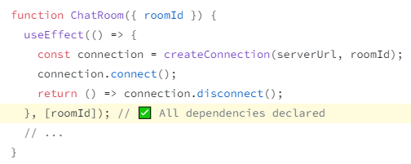
   2. 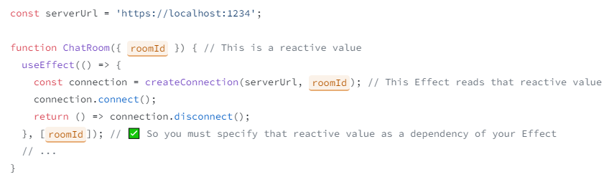
   3. 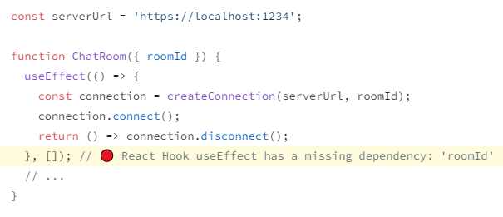
   4. 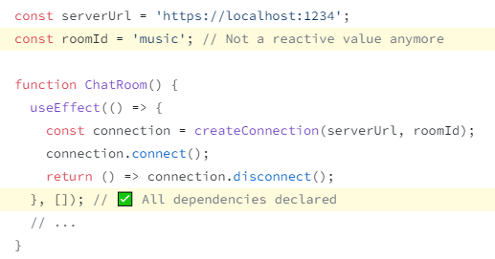
   5. 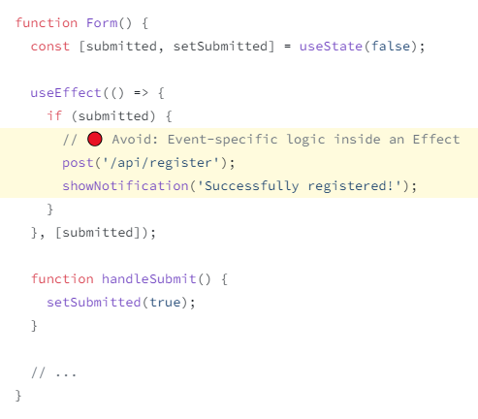
   6. 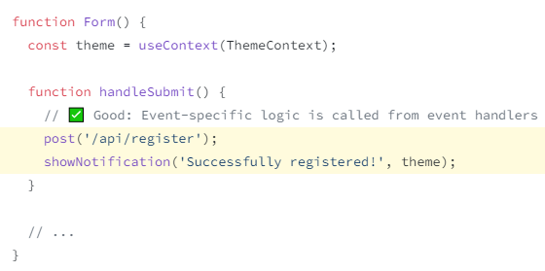

* 1. 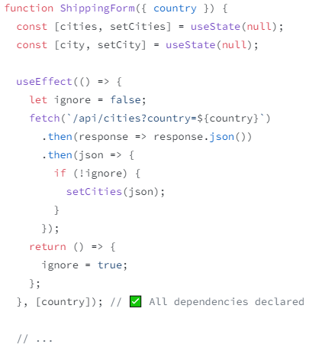
  2. Avoid: A single Effect synchronizes two independent processes means 2 api call inside single effect, you have to need 2 different effect for each api call

1. **API Integration**
   1. 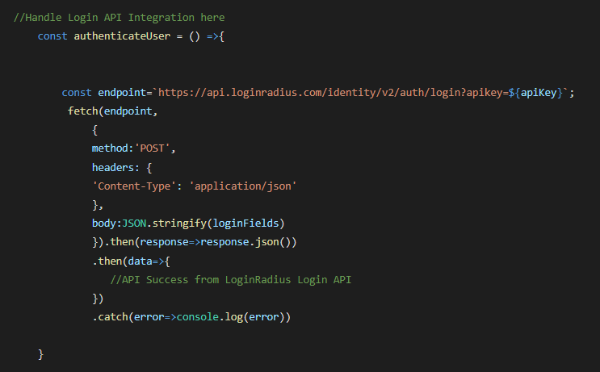
2. **What is Routing in React and how we implement it ?**
   1. Memory Router, Browser Router and Hash Router